Results
Choice of the observation model
A key aspect of deciding whether to use a Poisson or a Negative Binomial likelihood function for the HMC as part of the observation model depends on its ability to demonstrate good model fit. To quantify what is good, several metrics are used. In our case we used log pointwise predictive density (in-sample) as well as the difference in the expected log predictive densities between the negative binomial likelihood and the poisson likelihood based models.
In two separate arms based on the likelihood functions, the full-wave fits were used for the comparison (i.e. all observed days of a wave were used as the training data) Three outbreak waves were considered: Delta, late 2021, Omicron BA ½ early 2022 and Omicron Ba .4/5, mid 2022). [maybe this should go to the methods part]…
The ODE Model 1 fitted to the aggregate cases for the delta wave with the Poisson likelihood function demonstrated non-convergence. We suspect it happened because the Poisson likelihood could not explain the day-to-day scatter through an observation parameter without bending R_0 (t), the reporting fraction (i.e. case ascertainment rate) and the seeding (initial E0) to chase every “wiggle” in the data. This led to different chains finding mutually incompatible contortions that produced a multi-modal, funnel-shaped posterior with regions of wildly varying curvature. The NB arm gave the sampler an escape valve- the dispersion “phi” absorbed the excess variance without deforming the trajectory. This was one of the major justifiers for the use of NB likelihood
For the formal comparison exercise, therefore, the delta wave models were dropped and only the two omicron waves’ models were considered. Conditioned on sampler chains’ convergence, the NB model showed in sample lppd gap of about 41,800 and 32,000 log-likelihood units in NB’s favour.
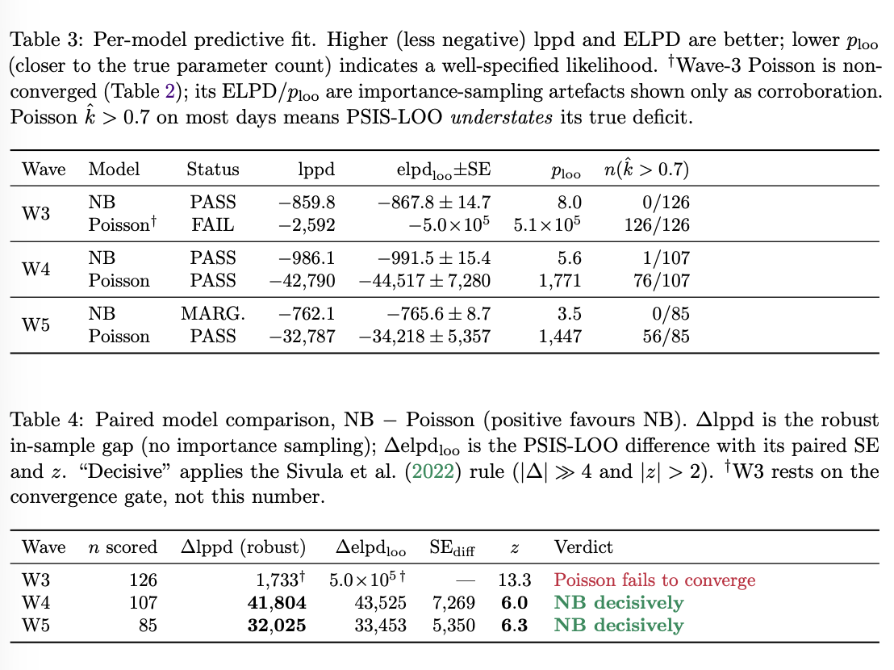
[Mention how NB showed superiority in in-sample lppd ]
Assessing Prediction Ability
For the purpose of analysing predictive performance, a modified version of continuous ranked probability scores was used to compare across different ODE model setups. {What modification did you do?}
If we use the crps function in R, what it does is compare an observed value with a distribution and then assigns a score. Now, the distribution comes from a model that has only training data but which forecasts into the future. CRPS can be used to assess with both in-sample data as well as out-of-sample data. I took CRPS of each day (training + test) and then cumulated them over time. Since the absolute values are too large, for the purpose of comparison, I converted to log.
This new form of assessment is useful to compare predictive performance across ODE model setups.
The simpler ODE models that did not have age or severity modeled into them were subjected to post hoc forecasts by using literature values of IHR, ICR, IFR. Population weights were used to forecast by age group. (I actually tested two different arms)- need to finalise which one suits better)
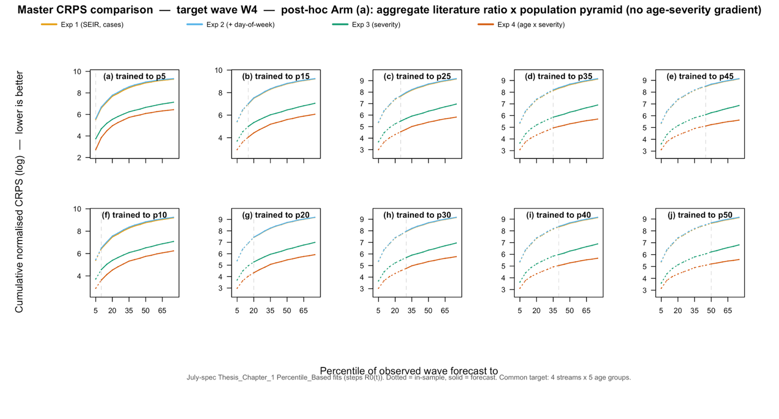
Continuous ranked probability scores for different ODE models that forecasted the first omicron wave with varying amount of data and with prior information obtained from the Delta wave. The dotted lines represent values for which data was part of the observation model likelihood while the solid lines represent the forecast values. As can be seen across the board, i.e. for any days of data added to the model(s), the ODE model incorporating severity and heterogeneity was the best performer. p* represents the number of days of data for that wave corresponding to the * percentile of information within that wave. For example, p30 of first omicron wave may represent 20 days of covid case data of that wave after the ODE model’s t0 was started (roughly into the omicron wave).

What does best mean in this case? It means that incorporating age as well as case severity heterogeneities, we are able to develop models that can forecast cases along these lines better than the ones where the ODE model is simple and all forecasts are done post-hoc using literature values. This is also true in situation where we may only have very limited data (p5 or p10)
What does this mean going forward? It is possible to build and train Bayesian ode models on exisiting rich data (if we have some) and then use limited data of new outbreak along with informative priors from previous outbreaks to get reasonably good forecasts across heterogeneities, which becomes quite useful for health policy planning.
However, the key hypothesis that is proved by the CRPS plots is that complex ODE models are needed in order to be able to do good predictive modelling.

